

a project on Impact on organic farming practices on crop yield and soil health



March 16, 2024

Contents

Introduction: 2

Objectives: 2

Methodology: 2

Sustainable Organic Farming 3

Bibliography 3

Positive Impact of Organic Farming 3

1.Crop Yield 3

2.Soil Health 4

3.Environmental Benefits 4

4.Economic Consideration 4

Discussion 5

1.Soil fertility 5

2.Effect of organic farming practices on soil physical properties 5

Expected Outcomes: 5

Bibliography 6

Impact of seven years of organic farming on soil and produce quality and crop yeilds in Bangladesh 6

Conclusion: 7

**Impact on Organic Farming Practices on Crop Yield and Soil Health:**

Introduction :

Organic farming could be an option to ensure food, air, water, and soil quality leaving the environment safe for the present and future generation. Long term field experiments have made clear the negative impact of continuous use of chemical fertilizers on soil health (Yadav,2003). Meeting the domestic food requirement has been the foremost social priority for India since independence. Vegetables play vital role in the health and nutrition of people. The food experts and nutritionists have realized and appreciated the food value of vegetables because of its low calorific value, high content of proteins, vitamins, and minerals. Hence, vegetables are the most essential crops in organic farming systems. India has vast potential of manurial resources. Farm yard manure and poultry manure are the most commonly used organic manures by the farmers in Kerala, the most southern State of India. Poultry manure is a rich source of nutrients especially for vegetable production. Vermi compost, which is produced by disintegration of organic matter by earthworms, contain high amount of nutrients, hormones, and enzymes, and has stimulatory effect on plant growth. Among the various vegetable crops grown in Kerala, cowpea occupies a prime position because it is an important protein source. Hence, studies have been carried out in cowpea (Vigna unguiculata subsp. sesquipedalis (L.)Verdcort) in order to monitor the changes in soil health, yield, and quality of crops under organic farming.

# 

# Objectives:

1. Evaluate the effects of organic farming practices on crop yield under diverse agroecological conditions and cropping systems.
2. Assess the influence of organic farming practices on soil health indicators, including soil organic matter, nutrient availability, microbial activity, and soil structure.
3. Identify key factors influencing the success of organic farming in maintaining crop productivity and soil fertility.
4. Explore strategies to mitigate potential challenges and optimize the benefits of organic farming for both crop production and soil health.

# Methodology:

Field experiments have been conducted at the College of Agriculture, Vellayani to evaluate the impact of organic farming practices over inorganic farming on soil fertility, yield, and quality of crops using cowpea as test crop for two seasons. Vellayani is located at 8030’ N latitude and 760 54’ E longitudes and at 29m above msl. The mean maximum and minimum temperatures that prevailed during the cropping period were 34.630 C and 20.210 C respectively. The mean relative humidity was 81.74%. The mean rainfall of the location is 1293 mm and the place experiences a humid tropical climate. The soil of the experiment site belongs to the soil taxonomic class loamy skeletal kaolinitic isohyperthermic rhodic haplustult. The experiments were laid out in randomized block design with eight treatments and three replications. The treatments consisted of: T1: Full recommended dose as per package of practices recommendation (20 kg N ha-1, 30 kg P2O5ha-1 and 10 kg K2O ha-1 with 20 t FYM ha-1); T2: Full recommended dose as farm yard manure; T3: Full recommended dose as FYM + P solubilizing microorganisms; T4: Full recommended dose as Vermi compost; T5: Full recommended dose as Vermi compost + P solubilising micro organisms; T6: Full recommended dose as poultry manure; T7: Full recommended dose as poultry manure + PSM; T8: Inorganic alone (20 kg N ha-1, 30 kg P2O5 ha-1and 10 kg K2O ha-1). Farmyard manure, vermicompost and poultry manure were applied on the N content basis and additional requirements of P and K were met through application of rock phosphate and ash according to treatments. Phosphorus solubilizing micro organisms consisted of a mixture of Pseudomonas, Aspergillus and Azospirillum. Phosphorus solubilizing micro organisms @1 g plant -1 was applied in T3, T5 and T7 treatments. Entire P and K were applied basally and half the recommended N as basal and rest after two weeks of planting for all the treatments. Lime has been applied to all treatments at 250kg ha-1 in order to correct the acidity problem. Phosphorus fixation by Fe and Al oxides is a problem in this soil. Hence P solubilizing micro organisms were used along with organic manures. For this experiment variety Sarika was used which is a trailing vegetable type with duration of 100 days. Soil analyses and plant analyses were carried out using standard procedures outlined by Jackson (1973), Black et al (1965) and Page et al (1982).

# Sustainable Organic Farming

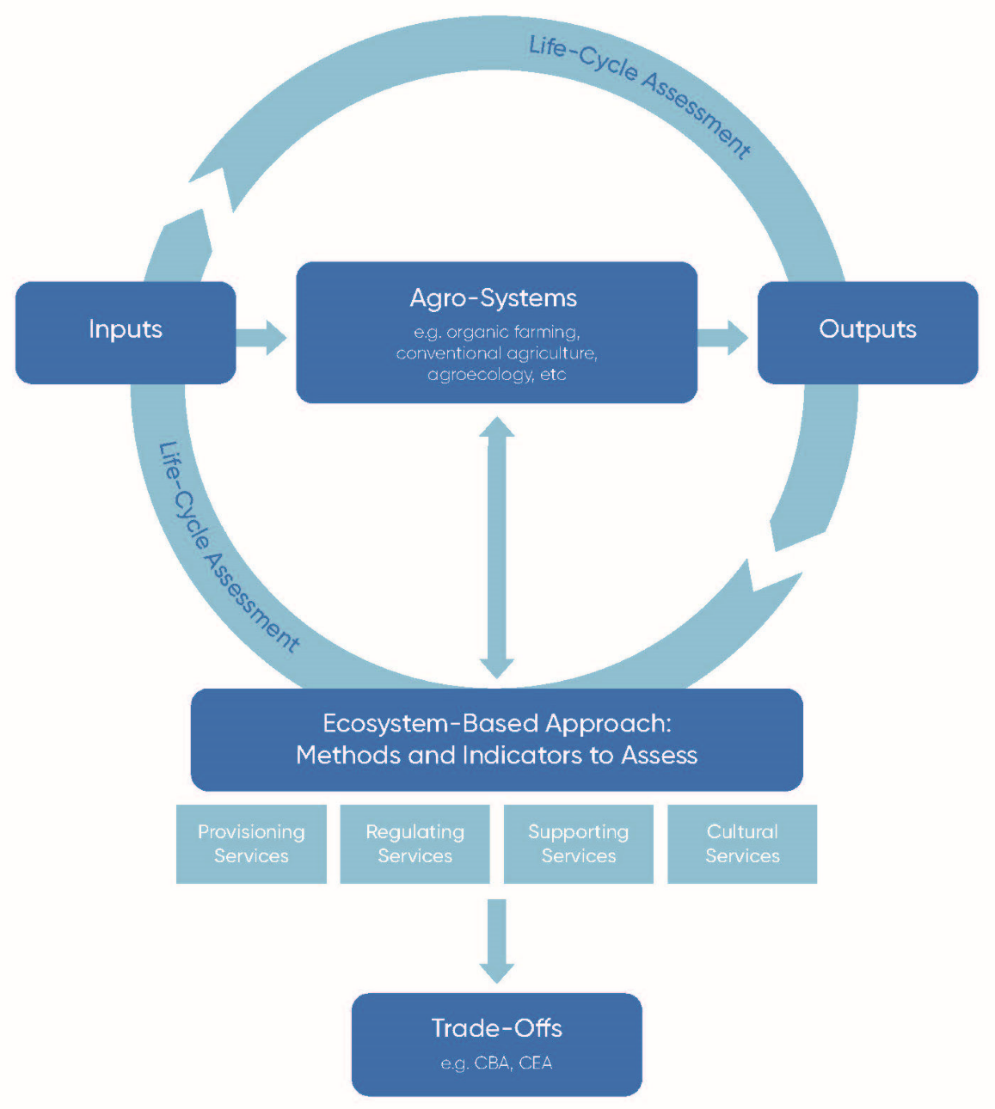

Figure 1:Sustainable organic farming system

(F.Muller, 2019)

# Bibliography

F.Muller. (2019). Sustainability in global agriculture driven by organic farming, MDPI.

**Discussion :**

# ***Soil fertility***: All the soil (0-20 cm depth) physical properties like bulk density, water holding capacity, porosity, and soil temperature were found to be significantly influenced by organic nutrition.

**Effect of organic farming practices on soil physical properties**:

|  |  |  |  |  |
| --- | --- | --- | --- | --- |
| Treatments | Bulk density (Mg m-3) | WHC(%) | Temperature  (0C) | Porosity (%) |
| T1 | 1.41 | 35.84 | 31.26 | 44 |
| T2 | 1.35 | 36.54 | 30.13 | 44.70 |
| T3 | 1.34 | 35.83 | 30.33 | 44.47 |
| T4 | 1.32 | 41.70 | 29.40 | 48 |
| T5 | 1.34 | 37.30 | 30.53 | 45.30 |
| T6 | 1.33 | 37.43 | 30.43 | 44.97 |
| T7 | 1.48 | 30.13 | 32.73 | 41.13 |
| SE | 0.01 | 0.59 | 0.15 | 0.32 |
| CD(0.05) | 0.03 | 1.79 | 0.47 | 0.58 |

In all the cases, vermicompost application (T4 & T5) has been found to be superior. According to Brady (1996), organic matter is the major component that stimulates the formation and stabilization of granular and crumb type of aggregates. As organic residue decompose organic acids, sugars, mucilaginous substances, and other viscous microbial byproducts are evolved. Which, along with associated fungi and bacteria, encourage the crumb formation and net effect of these activities will decrease bulk density and increase porosity as reported by Loganathan (1990). Higher organic matter addition could increase organic carbon content of the soil which resulted in an increased water holding capacity of the soil. The humus can absorb water two to six times its own weight. Soil organic matter is responsible to a great extent, directly or indirectly for making the physical environment of the soil suitable for the growth of crops. It exerted this benefit largely through its effect on improving soil aggregation and porosity, which in turn influenced soil structure, water infiltration, moisture conservation, drainage, aeration, temperature, and microbial activities. The treatments with vermicompost application registered superior values for all the soil chemical properties like pH, cation exchange capacity, organic carbon, and C/N ratio (Table.2). The increased level of organic carbon is a good indication of better carbon sequestration in soil by reducing the amount of CO2released to the atmosphere.

# Expected Outcomes:

1. Insights into the impact of organic farming practices on crop yield and soil health across diverse agroecological contexts.
2. Identification of key factors influencing the success of organic farming in maintaining crop productivity and soil fertility.
3. Recommendations for optimizing organic farming practices to maximize crop yield while enhancing soil health and environmental sustainability.
4. Contribution to scientific knowledge and informed decision-making regarding the adoption and promotion of organic farming as a viable agricultural strategy.

Figure 2: Application of Organic Farming (%)

# Bibliography

G.Oyedele, F.-A. (2018). *Agricultiural and Food Science.* Ondo State, Nigeria: American Journal of Agriculture and Forestry.

Impact of seven years of organic farming on soil and produce quality and crop yields in Bangladesh:

# Conclusion:

This project aims to provide valuable insights into the impact of organic farming practices on crop yield and soil health, addressing both the benefits and challenges associated with organic agriculture. By understanding the dynamics between organic farming practices, crop yield, and soil health, this research seeks to inform policymakers, farmers, and stakeholders on strategies to promote sustainable and regenerative agricultural practices for a resilient and healthy food system.

Top of Form